**Register:** To use appmust have account to create account as Doctor and doctor must enter all required information

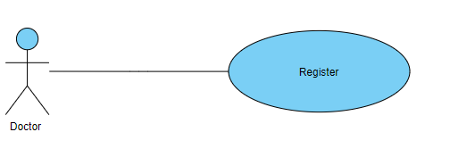

**Login**: To log in the app the user must enter username and password

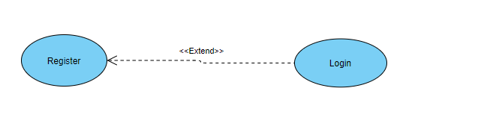

**Start Audio Recording:** Doctor start audio record to voice recording conversation between him and patient

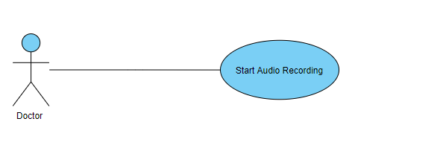

**Send Audio To API:** after conversation voice recording it will send to model to start classification

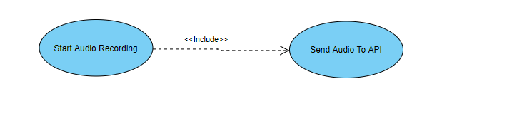

**Receive Audio:** server received the conversation

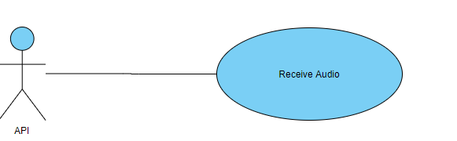

**Convert Audio TO Text:** NLP start preprocessing text by convert Audio TO Text

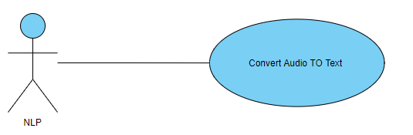

**Analysis Text:** NLP receive text after converting and start analysis text

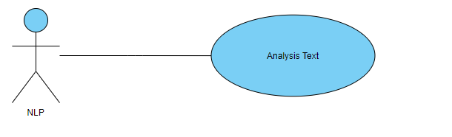

**Extract Symptoms**: NLP will Determines Symptoms after make Analysis to Text

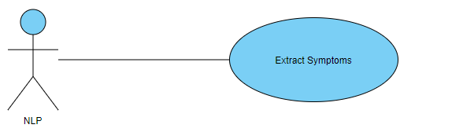

**classification Disease:** after Extract Symptoms Disease Classifier will receive Symptoms and predict Diseases

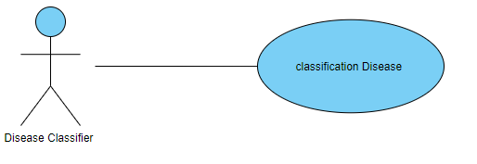

**Suggest Medicine**: after predict Diseases Treatments predictor will receive Diseases and Suggest Medicine

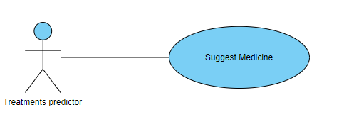

**Return Symptoms, Disease, Treatments:** after make classification Symptoms and Disease and predict with Treatments API will return what are Symptoms and Diseases and Treatments

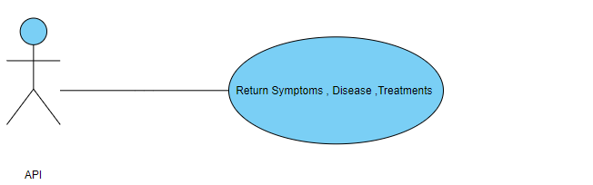

**Receive Symptoms, Disease, Treatments:** doctor Receive Symptoms and Diseases and Treatments that can use to make decision for patient Illness

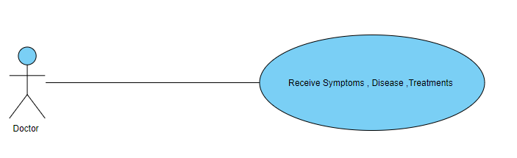

**Scan Patient QR Code:** Doctor Scan Patient QR Code To be able view patient medical history

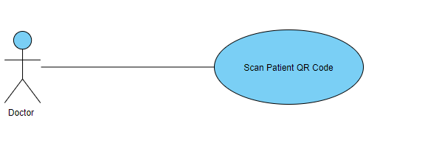

**Confirm result:** Doctor add record to patient medical history

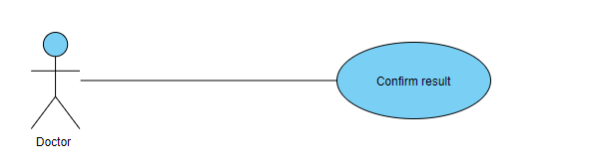

**Save Record:** send Record to API

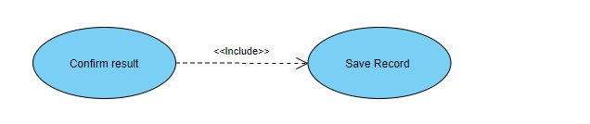

**Register:** To use appmust have account to create account as Patient and Patient must enter all required information

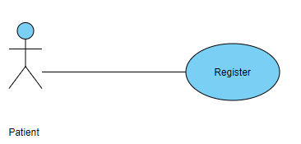

**Add Medical History**: patient add all old medical records

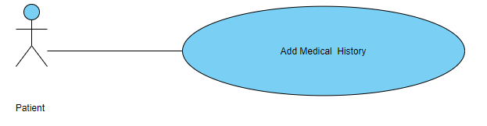

**Receive Medical History**: after add medical history API Receive Medical History and sent to server

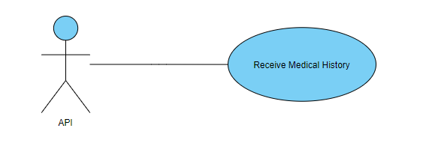

**Store Record:** Server receive medical records and stored 